PEACE AND ORDER

1. **CCTV**

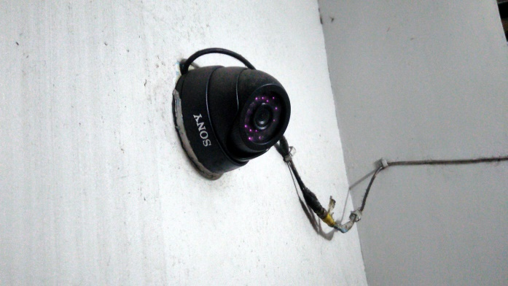

Closed-circuit television is installed had been one of the best evidence for crimes that had been committed. A lot of criminals had been caught because of these. In Baguio lots of these are now installed mostly in crowded places where lots of pickpockets’ are located. Most of the streets here in baguio, especially in town proper has CCTV.

1. **Traffic**

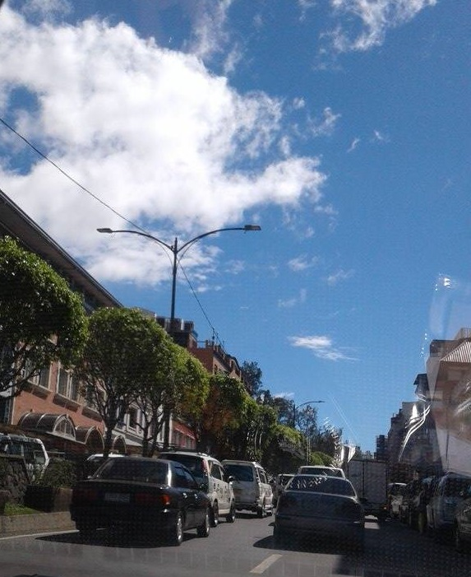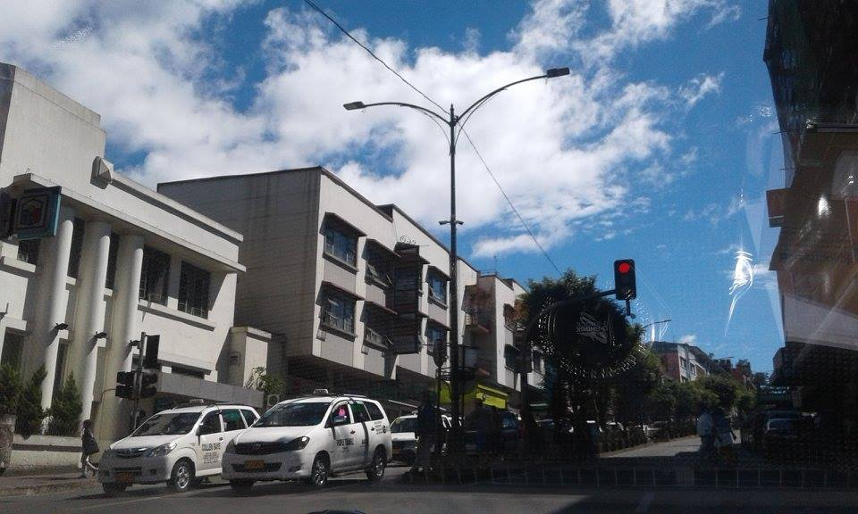

Traffic is one of the problems that people in baguio encounter.

1. **Jeepney passengers**

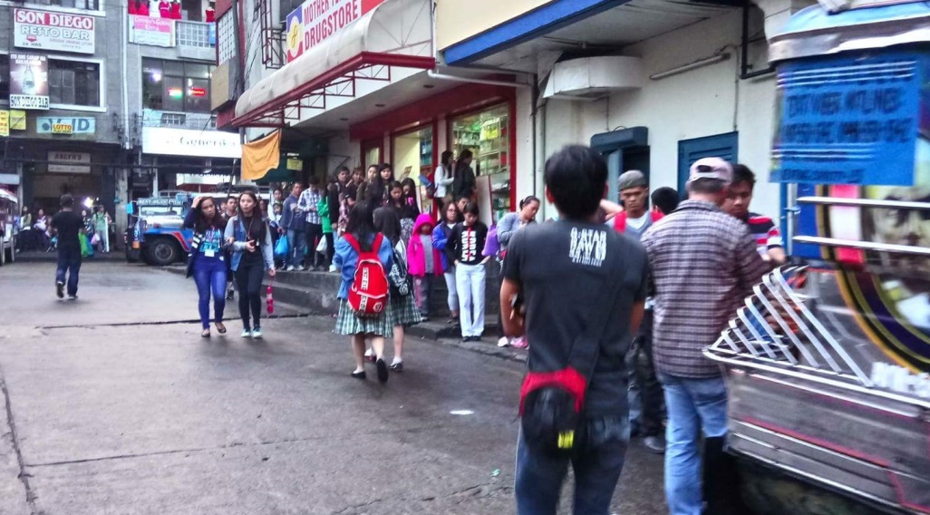  
Jeepney is the cheapest transportation here in Baguio. And because of that passengers need to fall in line and wait for their turn before they can enter. Growing population in Baguio resulted to longer lines of passengers.

1. **Police**
2. **Number Coding Scheme**